Written Review and Star Review

Khushboo Ojha

Harrisburg University of Science and Technology

Abstract

The online shopping has grown exponentially over the last decade. This in turn, has made the e -retailers to grow as well. E-retailers have allowed to customers to leave their response about the products along with the rating on their portals or webstores. The potential customers often look for something more than the product description and ratings before they make the decision to buy a product. Written reviews play a very important role here. The previous studies have shown that written positive and negative reviews are logical and contain facts why customers have chosen those products. This study we will cover how written reviews impact the product evaluation. We will also study the relationship between customers’ attention and production evaluation.

Keywords: Attention, Positive review, Negative review, Eye tracker

Written Reviews and Star Rating

Online shopping facilitates people to buy a product on the internet. Over the period, online shopping has become more popular as it saves time, traveling expense and it is flexible. Due to this flexibility, people are attracted to online shopping, and many companies find it as an opportunity and turn companies into e-business. Many unknown and brand-new companies in the market are trying to make a global existence and sell their product through e-commerce (Loane,2004). eMarketer (2017) in their report estimated total e-retail sales worldwide, and this report was prepared based on data from other companies and government firm. They determined that in 2015 the total e-retail sales were $20.795 trillion which was 5.8% increase, which later exceeded to $23.445 trillion in 2017 which is 6.3% increase, this sale has been forecasted to increase to $27.726 trillion in 2020.While these figures show that many people around the world are getting involved in online shopping.

On a website there is much other information which may or may not be related to the product, human gaze behavior revolves around that information to find the quality information which will reduce their risk of losing money and getting a high-quality product. Retailer highlights the positive features of a product, and there is not much information other than product description to make their decision. Thus, review plays a crucial role in their decision-making process.

The previous study has been done by Ashby, Walasek & Glockner, (2015) where they did their analysis on star rating scale and with the help of eye tracker, they did their research on human gaze behavior and attention allocation. They found that customers attention was more on star rating and based on that they evaluate the product. This study is a follow up of previous work, and we will proceed our study on written positive and negative reviews. This study is an attempt to find that due to cognitive biases and human behavior customers are focused to written positive and negative reviews other than star rating reviews before buying the product. We will look into decision making process of a customer based on another customers Experience.

**Literature Review**

E-retailers like Amazon, e-Bay, Flipkart provides a platform where a firm can sell their product, and the potential customer looks for the desired product. People prefer to buy products online as it is flexible, and they save time. As the trend of online shopping has increased over time, most of the companies are moving towards E-commerce. Egan (2016) in his report said that 15% of all Macy's department store is closing. It is believed that the rise of Amazon and other retailers is the reason behind the downfall of Macy's. Other than Macy's many other retailers like Target, JC Penny, Kohl's, Sears have declined to open over 100 of stores. As many retailers have started emerging into e-commerce, there is competition between retailers to attract most of the customer to their website and develop trust. However, to do so, the e-retailer should try to understand the customer's expectation and satisfy them with their electronic-Quality Services(e-QS).

According to Chaudhri (2000) introduced few elements of perceived risk in online shopping. First element is "Functional risk" which includes whether the product is worth that cost, is there any extra cost involved to the product purchase, risk associated to performance of the product if it product fails after it arrives, and risk associated to the security of online transaction, if the platform is safe to do online transaction, if someone does not hack any information related to credit card or account and privacy related to transaction is not disclosed and the second element is "Emotional risk" which includes image of the product which is built by potential customer itself, it may happen after seeing the picture of the product. Emotional risk also involves the feedback from other people, personal opinion from other people or market trend. According to Bagozzi, Tybout, Craig, & Sternthal, (1979) cognition, individual experience, and behavior, the attitude has a greater influence on perceived risk. Personal attitude may affect the decision making of a person by persuasive communication, and his message may influence the other person, these messages are emotional and sensitive that it greatly influences one and thus it affects the decision of the person, and hence its impact on perceived risk

The e-retailers provide information for the product and reviews of the product but to build trust and gain customers the attention they should provide quality services. Sarmah & Sarma, (2011) through their studies have made a list of factors which should be included in e-SQ and which are important in increasing the usability "Information", "reliability", "time", "simplicity", "ease of remembrance", "proper level of personalization", "delivery time", "choice of payment", "multiple delivery of time options", "site aesthetics", "fast and easy transactions", "clear instruction", "easy check-out and accurate transaction ", "safety" and "security", "internal and external collaboration", "willing to respond to customer need", "prompt handling of enquires", "interest of problem solving", "Compensation for mistakes made by the site", "good return policy", "correct refund of returned products ". Tsao & Tseng (2011) concluded that there is a positive impact of e-SQ on the brand equity of a website they also stated that if the brand equity is higher, then the degree of perceived risk is lower.

Though the e-retailers provide many information and cues, social based cues are one of the important cues about the product. With the internet and the innovation of information technology, it has enabled consumers to share their personal experiences about the product and help other potential customers in their purchase (Avery et al. 1999). This method of online review has gradually become a significant method for providing word-of-mouth information about the product (Chen, Luo, & Wang.,2017)

To understand customers perception, companies like Amazon, e-Bay, Flipkart and many other e-retailers allow a customer to leave their response about the product, and these customers are the people who have already bought the product. Customers reviews are in the form of written comment and reviews based on a star scale. In Amazon, a 1-5-star scale associated with the customer's comments and this star is calculated by the website based on customers positive and negative review. Flipkart, India's one of the retailer allow the customer to leave their review based on stars or by written comments thus, for each product on Flipkart two types of customers responses are available, i.e., Rating (star rating) and Review (written feedback). Some e-retailers allow the customers to share their experience about the product as a written review which eventually converted into a count of positive and negative reviews. Amazon has added a program "Amazon vine," this program was created to provide customers with more information about the product which includes an honest and unbiased review from some of the Amazon's most trusted reviewers. These Amazon believed reviewers are the people who continuously provide their helpful (positive or negative) reviews about the product which is judged by the potential customer whether the information is useful or not and thus depending upon the helpfulness they become expertise for a product. Therefore, the different online retailer a response from customers in a different way either by the written review, rating, vine customer, question and answer from certified customers. Action loyalty refers commitment to a product and future purchase of the same product despite competitors and competing for the product(Oliver,1997). Similarly, we can say if a marketer has achieved customers trust and the customers become loyal to that firm then they tend to buy products from that platform (marketer). Customer's review is directly related to sales and brand loyalty (Voight, Joan.,2007).

Though the retailers provide information about the product, reviews the question arises, do customer pay attention towards this information before purchase? Is this information relevant to them? How many people use this information? Because if a customer doesn't find the info concerning then loading this information on the website is a burden on the server side. In February 2016, a survey was conducted on US internet users by Trustpilot, and their intention was to find if the customer considers reviews as essential information and do they use this information? Their finding from this survey was surprising, 80.7% of users believe that review was necessary, and they refer reviews before making their decision to buy or is willing to buy the product whereas 4.7% of users didn't think that review was not significant. They also studied about customers behavior and frequency of using review, they found that 18.5% of users read the review before visiting company's website, 24.7% read the review on company's website but before they start shopping for the product, whereas 46.6% read the reviews on company's site before adding that product to their cart, whereas 8.4% read the review before checking out (eMarketer). Thus, this study is a shred of evidence that review plays a significant role in shopping and this tool influence the potential customer and help them in decision making.

Depending on above studies we can say that if a product is reviewed a higher number of positive and negative reviews it will influence the customer and it will affect the sales of a product. Chevalier and Mayzlin (2006) studied about online book sales at Amazon, and they analysed that customers respond to the book influences its sales. Similarly, a study on movie box office was done by Zhang & Dellarocas, (2006), and they found that customer review affects the total sales of the product. Thus, the positive review can affect sales and product evaluation, customers pay attention to a positive review, and hence the product with less review is not paid attention.

A study was done to find if the negative review has an adverse effect on sales, to see that the author did analysis on "New York Times Reviews" on a book and found that though a book got negative reviews from New York Times, the sales for the book was high. The author suggested that the reason behind the high sales is the platform on which it is graded. This means that the platform on which the product is reviewed makes the difference in sales. If a product is evaluated on a standard platform it is also an achievement, it seeks people's attention and influences the decision (Berger, Sorensen & Rasmussen, 2010). The positive review or negative both can influence the potential customer's decision-making strategy, and it depends upon customers behavior and cognitive biases which affect the final decision of the customer

On a website, a customer is provided with lots of other information like product information, reviews, question, and answer, offers, size of the product, advertising or advertising of other products. Thus, to find customers interest, we can observe their eye movement. Eye movement is consisting of two different components, Fixation and Saccades: (Wedel & Pieters, 2008). Saccades are one of the types of eye movement where the fovea moves quickly from one point to another, and its average duration is 20-40 millisecond. A human being makes 100 to 70,000 of Saccades a day. Fixation is slow movement of fovea which lasts between 50-600 millisecond (Rayner & Keith,1998). During Fixation, the fovea is aligned to an area for the longer duration of time. Consumers have limited capacity to process all this information and rely on intuitive and effortless thoughts (Fiske & Taylor, 1984). So, if a person just gazes through the data, it's called saccades. The brain has evolved an attentional mechanism that selects a subset of relevant information for enhanced processing. When attention chooses a section or object in an area, Processing of it is improved, and processing of its non-selected area is simultaneously suppressed (Wedel & Pieters, 2008). A. Drift-diffusion model is used to find the correlation between attention and decision-making process. Drift-diffusion model allows to decide between two elements by randomly selecting the data from the sample, and the items which have more positive values are agreed to be chosen over the other item (Ashby, Walasek & Glockner, 2015).

As discussed earlier, reviews of a product are done using star scale rating or written review. The motive of the previous study by Ashby, Walasek & Glockner, (2015) was to evaluate a product and make their choice based on visual attention on star rating. However, in contrast to it, this study is performed on an additional factor, i.e., written a positive and negative review. This study suggests that before buying a product a customer’s decision-making capability is based on written review and not just on star rating. Using 1-5 star review the consumer tend to provide rating for overall product, whereas in contrast, written review is more informative as it includes detailed information about the product like design, color, quality, easy to handle, etc. thus the consumer prefers written review over star rating (Utz, Kerkhof, & Van Den Bos ,2012). Ashby, Walasek & Glockner, (2015) came up with their three findings. Firstly, they concluded that if a product is rated by a large number of customers than section seeks more attention of the potential customer. In contrast, if the written comment is available then the customer’s decision-making strategy is influenced by the written reviews, to find the reason behind customer response irrespective of negative or positive reaction. The star rating depends upon customers concern and experience, and they are not forced to provide any logical reason behind their view. Thus, customer attention would be to find a valid reason for the negative response. Features of standard review are that it should be reasonable, convincing, more rational and logic of choice should be justified with regards to reality and facets (Park, Lee, & Han, 2007). When a written review is available to a customer, then human behavior and decision-making process are influenced by marketing cognitive biases. Customers do not have a structured method for preferences. If a customer wanted to make their preferences than they need to evaluate the product (Bettman, Luce, & Payne 1998). Based on previous studies researchers stated that visual perception is an important role in visual attention and it is performed at the final stage while making choices. A person’s preferences at the final stage is treated as an alternative, depending upon preferences which have been already made Shimojo et al. 2003. Shimojo et al. (2003) during his analysis conducted where he had two choices and he analysed the data he got from participant gaze and he concluded that when a participant has some preferences then the attention to that section is very fast and they finally concentrate in the final point when they make their choices. There is no fixed approach (Top-down approach or Bottom-up-approach) of scanning the information. However, with experience of taking the decisions, there is the increase in fixations on essential facts and statements whereas fixation decreases for the data which are least concerns (Jacob, Martin, & Simone, 2013).

If a person must build a high-quality story or convey all his thoughts with details and facts, so that the listener is convinced then, they should use preposition and conjunction Tausczik, & Pennebaker, (2010). And when a high-quality story is built, then it is straightforward for a less knowledgeable person to understand your views (McNamara, Kintsch, Songer, & Kintsch, 1996). Chevalier, Judith & Mayzlin, (2006) Studied about the impact of word-of-mouth (written review) on sales. The review of the similar book was referred to two different e-retailer, Amazon.com and Barnesandnoble.com through the books got positive reviews, but the sales differ for both the retailers. The authors analysed that sales of the book on Amazon.com were more than the other. The reason behind the difference in sales is that Amazon.com had many reviews, and the quality of the review was different from Barnesandnoble.com. Quality of the review includes the length of review, logical, reasonable. Thus, they concluded that the written review and its quality influence potential customers. Therefore, we can say that high-quality review seeks more attention, some comments may be of few lines, and some comments may be of multiple lines but if the customer has provided the logical reason behind his choice this may influence the potential customer's decision and achieve more attention. This state that potential customer would instead read a lengthy review to get more information about the product which will help them to in decision making. A review with average rating is confusing. If a product receives average rating then it would confuse the potential customer as it doesn't explain much about the product in response to which according to Chevalier, Judith & Mayzlin, (2006) in this situation the customer would instead read the positive and negative review though it is short or long in length, but they won't solely trust on average star rating which is provided by e-retailer. The average star offered by e-retailer is based on some computation which is performed on the review. The number of reviews also influence the customer as it represents the number of people who have already bought the product it predicts the popularity of the product. Though many people don't post the review. But it gives an estimation of a customer who has bought it. If someone intend make a good decision, then they should be aware about all the properties of the product which they are intending to buy beside that they should be aware about the choices. Since they complicate the entire process situation as the customer get affected by cognitive biases or competing product feature. They made modification to drift diffusion model to binary attribute attention drift diffusion model which tells us about process involved in choices and how does that influence the visual attention. They found positive correlation between variables that accepts and rejects the decision. This decision was made based on quantitative prediction Luzardo, Rivest, Alonso & Ludvig. (2017).

So far, we came to know that reviews are critical to customers. Written reviews are more helpful for potential customers, and it receives more attention than rating stars as it is informatics. Attention to a section and number of fixation may help customers decision making strategy. For a customer building, a decision-making strategy will be time taking process and number of fixation to section will be more if the customer is new. Once they become more efficient in implementing decision making strategy, number of fixation for the same section and total time taken to make a decision also decreases. After constant process there will be a change in eye fixation as customers decision-making strategy keeps on changing, their behavior of finding information also changes. They become more efficient in building strategies. There is no fixed approach (Top-down approach or Bottom-up-approach) of scanning the information. However, with experience of taking the decisions, there is the increase in fixations on essential facts and statements whereas fixation decreases for the data which are least concerns (Jacob, Martin, & Simone, 2013). Though the reviews play a vital role, however, social decision-making strategies, human behavior, cognitive biases and attention to a part of the message may influence the final decision of buying or considering buying the product. Cognitive process is the group of tasks which is involved r help the brain to take their final choice, and it is an ability which mind has developed to take the decision. There are multiple types of a cognitive process like attention, memory, perception, etc. these processes help the brain to take an efficient choice. According to Lewandowska, & Jankowski. (2017). Cognitive process is a stops mind to think of the advertise and use personal attention process to take a decision. The e-retailer try to influence the customer through different cognitive biases. Cognitive biases are a pattern which affects the cognitive process of a person. Sometimes cognitive biases control the behavior of a person and lead to incorrect interpretation, lack of logical decisions and reduce the efficiency of cognitive process whereas sometimes it may be useful and help us to make correct and faster choice. Biases can be many types some of them are, biases for a group of people or individual person such as risky shift, some biases affect decision making, some biases can affect the judgemental process of a person, biases that affect memory, biases which influence you to consider irrelevant information and ignore relevant information, some affects judgement and decision making both. Thus, biases can be either improve the efficiency or degrade the efficiency.

When a product is bought online, we cannot physically inspect the product. Hence, we believe what we see. Based on above studies, we can say that reviews play a vital role in customers decision making process. In this paper, we will be studying customers attention and cognitive process on written reviews. We will also be studying about the impact of customers attention on product evaluation. Based on the above studies, it is hypothesized that greater proportion of on attention is on written reviews than star scale review. The product description will always emphasize on positive features of the product hence our next hypothesis is negative written reviews will achieve more attention (eye fixation) than positive reviews from a potential customer as based on its customers make their final decision. Our third hypothesis is that higher the proportion of attention in on negative review lower is the product evaluation. And our last hypothesis is higher proportion is on logical reviews rather than short or long reviews.

**Method**

Participants

The participants are the customers who have shared their personal experience about the product. A list of 71,045 reviews for 1,000 products was shared by Datafiniti’s product database. This dataset is the sample data of the actual data and it is available on Kaggle. These participants were both women and men and there is no age limitation. This data is collected from many websites hence there is no specific ethnicity of the customer. The data is not specific to any region. The observation in the dataset is randomly selected from the actual database. The reviews for these 1000 products were not specific to any company.

Process and Activities

The sample data is accessible on Kaggle. This data is being provided by Datafiniti. Datafiniti are one of the service providers who make the data available to customer on demand. They automate the process of extracting the data from web page. They transform the web page into structured dataset. They also allow the customers to query the data and drill down to the exact information they require. Datafiniti has data about business, people product and property. The data about the product is provide by them as sample and to explore the data. Customer’s share their reviews on different websites. Datafiniti access those websites and collect the data from different websites and merge them all together in a single data set. All the product has a key associated to it. This key is provided by Datafiniti and while collecting the data the data is merged depending upon key value.

Procedure

This dataset is freely accessible on Kaggle website. The data is available is CSV format and the description about the variables are available and for detailed information about the data are provided through a link. This dataset can be directly downloaded without having account in Kaggle. This data is web scraped. Each product in the data set may have multiple key. These keys help to merge the data from different websites. Hence, key for different product from different sources may vary.

Measures

I am performing analysis on R Programming in RStudio. We have loaded the data in RStudio. The dataset was consisting of 71044 observations for 25 variables. This dataset is consisting of data for following variables.

Brand: The brand name of the product.

Categories: It is the list of categories under which this product is included across the multiple source.

Data Added: The data on which this product was first added.

Date Updated: Most recent data on which this product was updated

Ean: This is a code associated with the product. Each product may have multiple EAN depending upon the variation where each using different EAN.

Keys: This key is generated by Datafiniti identifier. This key is used to merge all the raw data each time when it is accessed.

Manufacturer: The manufacturer of the product

Manufacturer number: A number/code for each manufacturer.

Name: Name of the product

Review date: The date on which this review was posted.

Review Date Seen: A list on dates when the review was seen

Did Purchase: True or false value if the reviewer has purchased the product.

Do recommend: True or false value if the reviewer has recommended the product

Id: The Id of the website where the review for the product are seen.

Numhelpful: Number of people, who found the reviews helpful

Rating: Star ranging from 1 to 5.

Source URLs: List of URLs where the review was seen

Text: The review text (written review) for the product.

Title: Title f the review title.

UserCity: The reviewer’s city.

Username: Reviewer’s username

We will be performing quantitative and qualitative data analysis on this data. We will also be building Machine learning model for predicting the data. Before applying the statistical method and machine learning approach to the dataset we need to understand the data. There is no dependent variable in the dataset. Dependent variables are the variables whose values are dependent on other variables and the variable on which it’s value is dependent is called independent variable. Dependent variables have correlation with independent variable. Hence, a change is independent variable will influence the value of other.

In the exploratory data analysis, analysis is done using histogram, bar plot, ggplot, scatter plot boxplot. There are 581 product categories in the dataset where as there are 392 brands who are selling this product. There are 464 manufacturer who have manufactured these products. The liker range of star rating is from one star to five stars. In figure1, we have plotted star rating using histogram. Histogram is used to plot the integer value and it is used to plot the frequency of occurrence of a value. We used histogram for this plot because the star review has numeric data type and this point of time we are not concern about the products and brands who got that response. We are concerned about the occurrence of each star rating. We can see that people who have reviewed the product have given 5 stars to the product. It is seen that there is no missing value for the star rating.

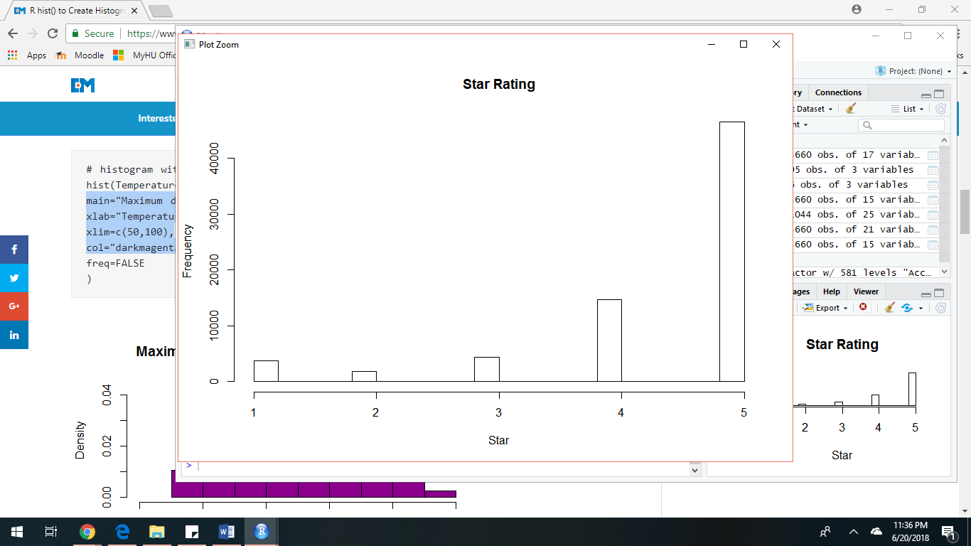

There are 71044 written reviews in the dataset. There is no missing data in the written review. These reviews include all short and long reviews. These written reviews include all the positive and negative review. Word cloud is the easiest way to visually find the most frequently used words in the text. It is most frequently used for text mining. Before forming word cloud, we need to clean the text. The written review(text) is consist of punctuation, preposition, space, capital and small letters, special characters. Hence, before building word cloud we will first convert all the character into small letter (small alphabets), and then remove all the special characters from the text and replace it with blank space. Once the blank space is inserted there will be gap between the words. Hence, we need to get rid of those blank space. And form a matrix of those words and their frequency. Table 1 represent the frequency of top 10 words used in the reviews. We can see that most frequent word used in the review is “this”.

|  |  |  |
| --- | --- | --- |
| Table 1. Frequency table for top 10 words used in the review | | |
|  | Word | Frequency |
| this | this | 2057 |
| product | product | 1428 |
| great | great | 1427 |
| movie | movie | 1425 |
| review | review | 1302 |
| part | part | 1278 |
| love | love | 1218 |
| collected | collected | 1216 |
| promotion | promotion | 1215 |
| the | the | 940 |

Based on this frequency of word we can build a world cloud. World cloud is a visual representation of the words occurring in the sentence. The word which has the highest frequency of occurrence is bold and its font size is higher than any other occurring word. Word cloud is simple and easy to understand. Below is the word cloud for the text review in the dataset. In figure we can see that “this”, “great”, “movie”, “review” are some of the words which are frequently used.

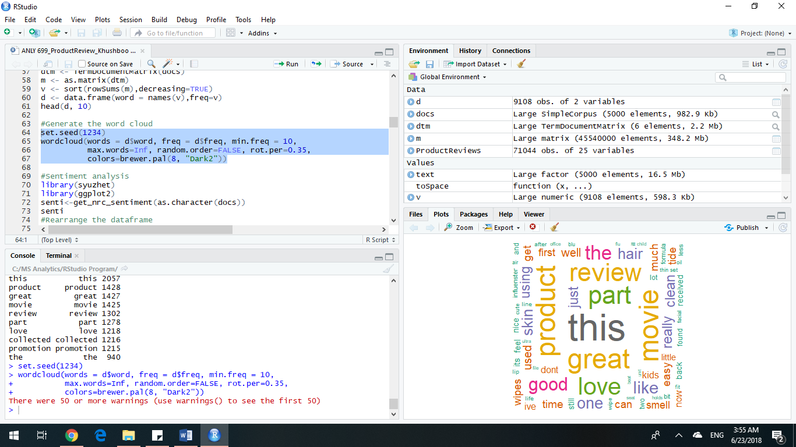

In the above word cloud, we can also analyse that there are few words with small font size like “life”,” lip”. Word cloud represent most of the frequently occurring value. For the above word cloud all the observation in the dataset were not used as we were running out of memory. Hence, we have randomly selected 5000 values from the dataset and after pre-processing the word cloud is build.

Sentiment Analysis is the process of mining the text and understanding the human sentiments and getting information about the source. While a customer reviews a product, they express their emotions through words and sentences. Sentiment analysis is one of the important classification method which helps us to monitor public opinion and extract the insight. Sentiment analysis can be done in two ways, one is by using the function and other is by building a “bag” with all the possible sentiments. To perform sentiment analysis, we need to get the review_text and pre-process it by remove all the special characters, English stop words and trim the white space between the word. get_nrc_sentiments( ) in “Syuzhet” package is a build in function which has list of words and the sentiment associated to it this function help us to find the sentiment behind a review. In Table2 we can see the sentiments associated to the reviews. There are 9 different emotions in the review.

|  |  |
| --- | --- |
| Table 2. Sentiment Analysis | |
| sentiment | Numbers |
| anger | 229 |
| anticipation | 267 |
| disgust | 197 |
| fear | 259 |
| joy | 259 |
| sadness | 237 |
| surprise | 162 |
| trust | 350 |
| negative | 585 |
| positive | 724 |

For the above table we have randomly selected 5000 words and predicted the sentiments in the review. There are 724 reviews which are positive, and it is the highest value in the table where as 162 reviews were surprise. A review is said to be positive, negative based on the selections of words in the review. In figure The sentiments of the review is represented using Barplot. It helps us clearly visualize the data.

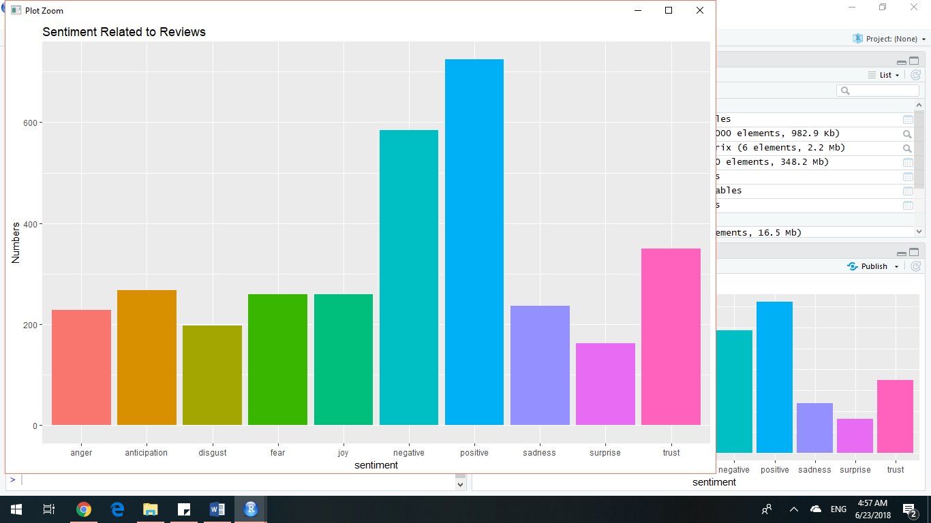

The reviewer has reviewed the product based on their product experience, their response is also added for another field i.e. do they recommend it to other customers. This information about the product also helps the customer to make their decision. It has been seen if a product is being recommended by most of the customer it may influence the customers decision making process. In the below, chart we can see that though most of the people have provided their response as 5 star, there is a thin line in the bar plot at top. Hence, there are few people who don’t recommend that product. But most of the people recommend the product. There is some missing value for the below variable. From the below plot we can also analyse that for the 3star rating there is a large population of people with different response. 3 Stars is said to be neutral response.

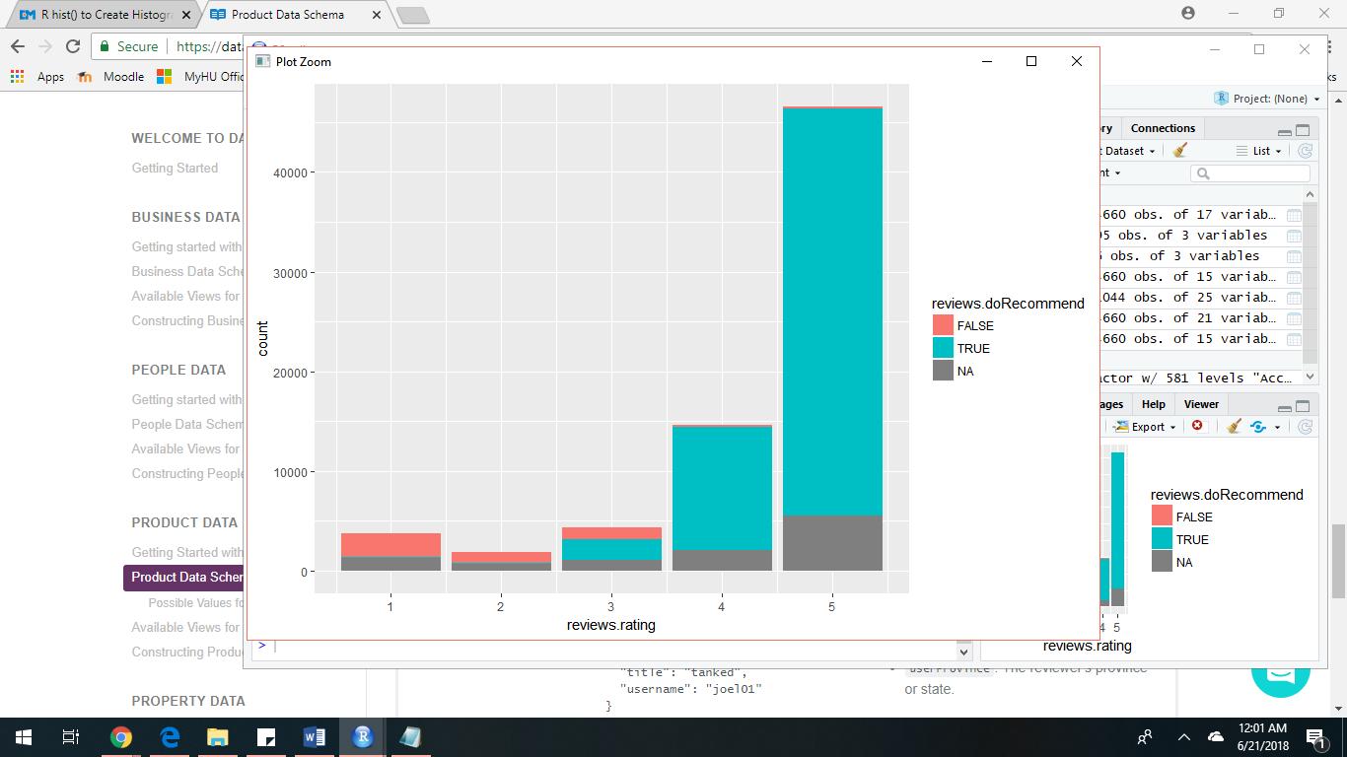

The next variable to be analysed is did the customer find the review helpful. Every customer has their own preference and concerns which may affect their decision-making process. Reviews are customers personal experience and they judge the product based on their concern. However, it might be possible that other desired customer is not concern about the fact based on which the review was posted. Hence that particular review is not relevant, and it would not influence the customer’s decision-making process.

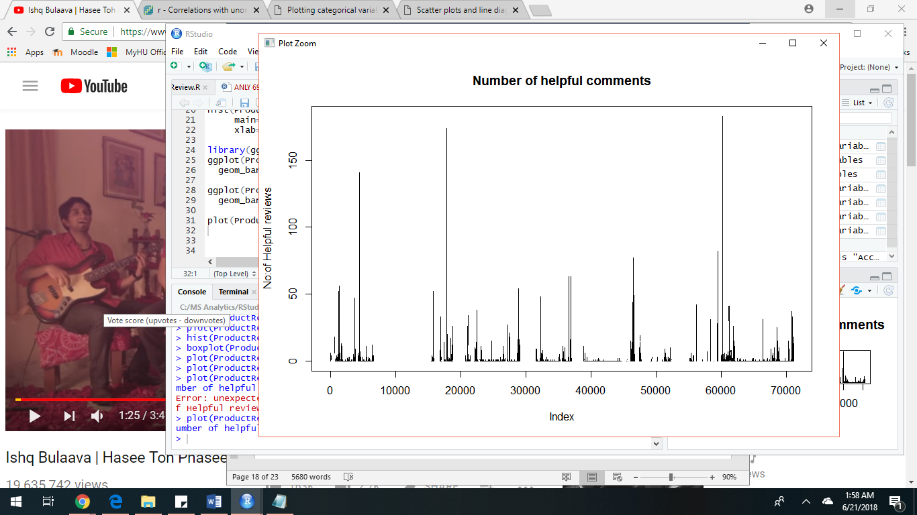

review_didpurchase is a variable which stores a binary value. If the reviewer has purchased the product. There are large number of missing value for this variable and a large number of customers didn’t even buy the product.

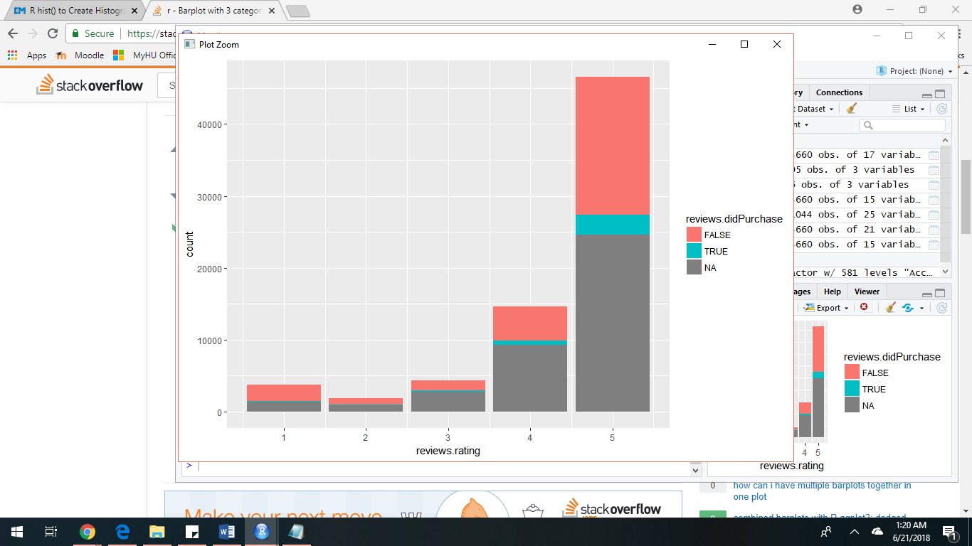

In the above graph we can see that many people didn’t even purchase the product then the question arises if they didn’t even buy the product how they reviewed the product. Hence, we can say that those reviews are fake. We don’t have relevant information about the reason behind not purchasing the product. Let’s assume one of the reason behind not purchasing a product may be because they would have returned it back. Based on that scenario we would expect that product should not be graded 5 stars.

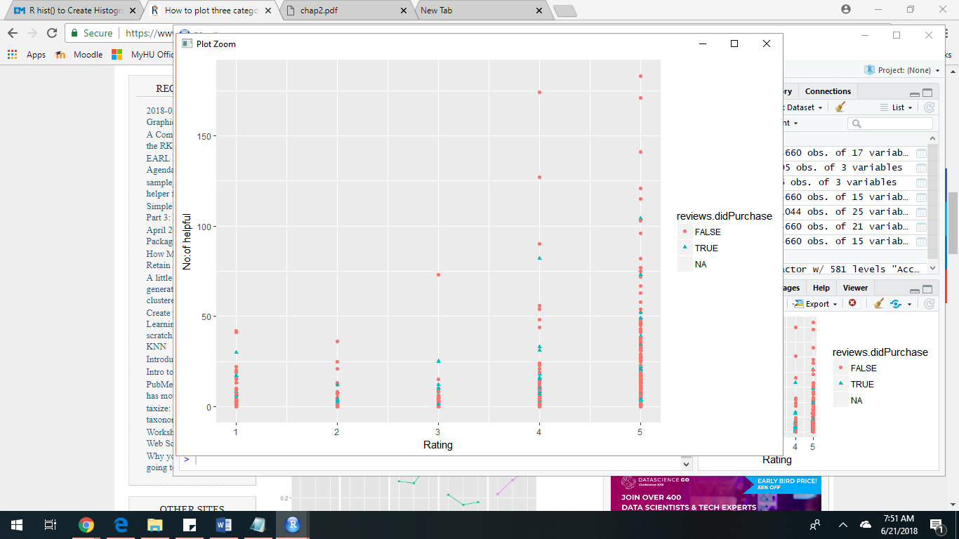

Building models

Machine learning is the process to train the machine and make it capable to make decision. The machines are trained based on the data available. The data are divided into training and testing data. With the help algorithms the machine is trained on training data and later it is learning is evaluated with the help of testing data. Algorithms are built to enhance the capability of the machine and train them to learn from past experiences and perform operations based on the data and requirement. We don’t train the model on total data as we will be out of data to test it and training and testing the model on same data will always give better result as it is familiar to the data already. In future new data arrives in the model there are chances that model would fail to give us correct response. Learning are of two types, supervised and unsupervised. Supervised learning is implemented on this paper. Supervised learning is used to make predictions. There are multiple algorithms in supervised learning, and each method is used based on predictors data type, target data type. In this paper some of the algorithms are based on our requirement and data type. For method 1, logistics regression is implemented. Our hypothesis is to predict if based on the star rating if the desired customer will find the comment helpful. We will be using logistic regression in this scenario because the target value is binary value. For building model, feature selection is done. Having multiple features may lead to overfitting thus we selected reviews_rating and num_helpful for building model. Based on the num_helpful, Is_It_Helpful variable is created. Thus Is_It_Helpful is a dependent variable. And it holds a value whether the review was helpful for the desired customer. It doesn’t matter the number of people who find it helpful. Is_It_Helpful is target variable. Later the data is split into training and testing where 70% is training and 30% is testing. Now we train the model and found that the value of deviance residuals is ranging from minimum 0.5097 to maximum of 2.2221, the value of P is 2e-16 and it is very small value which is less than 0.5.

|  |
| --- |
| Table 3. Summary of the model build using logistic method |
| Call:  glm(formula = Is_It_Helpful ~ reviews.rating, family = binomial(link = "logit"), data = train) |
| Deviance Residuals:  Min 1Q Median 3Q Max  -0.5720 -0.4539 -0.4197 -0.4197 2.2241  Coefficients:  Estimate Std. Error z value Pr(>|z|)  (Intercept) -1.56284 0.10894 -14.346 < 2e-16 ***  reviews.rating -0.16449 0.02432 -6.763 1.35e-11 *** |
| Signif. codes: 0 ‘***’ 0.001 ‘**’ 0.01 ‘*’ 0.05 ‘.’ 0.1 ‘ ’ 1 |
| (Dispersion parameter for binomial family taken to be 1)  Null deviance: 13958 on 22754 degrees of freedom  Residual deviance: 13915 on 22753 degrees of freedom  AIC: 13919 |
| Number of Fisher Scoring iterations: 5 |

Hence, our null hypothesis is not accepted. Beside that a chi-square, one of the statistical method ran on model this method is used to analyse the deviance in the model. Table3 is the table for analysis of deviance.

|  |  |
| --- | --- |
| Table 3. Analysis of Deviance using Chi-Sqaure test | |
| Model: binomial, link: logit | |
| Response: Is_It_Helpful | |
| Terms added sequentially (first to last) |  |
| Df Deviance Resid. Df Resid. Dev Pr(>Chi)  NULL 22754 13958 | |
| reviews.rating 1 42.779 22753 13915 6.128e-11 *** | |
| reviews.rating 1 42.779 22753 13915 6.128e-11 *** | |
| Signif. codes: 0 ‘***’ 0.001 ‘**’ 0.01 ‘*’ 0.05 ‘.’ 0.1 ‘ ’ 1 | |

From the output of the chi-square method, it is clear that initially the deviance was 14.675 and with the help of model the deviance changed to 13657. Greater the deviance better is the model. It can also be analysed that 22753 points were improved with the help of this model. Later, once we analyse the response we will fit our model based on test data. Once the model is fitted to test data. Misclassification in the data is analysed. Misclassification is when a particular point is misinterpreted and falls into another category where it doesn't have any similarity. Thus, due to which we will we will be provided incorrect information about the point and the association between the points. Outlier in the data can also lead us to misclassification. Table 4 shows the accuracy of the model is 91%.

|  |  |
| --- | --- |
| Table 4. Table for accuracy of logistic model | |
| Accuracy | 0.915615707987286 |

It seems that the model is good model based on accuracy. It might be possible though the accuracy is high but some of the observation is predicted incorrect i.e. misclassified thus performance of the predicted value is predicted using prediction method. Belo plotted is the AUC graph, from the below graph we can find the performance of the model.

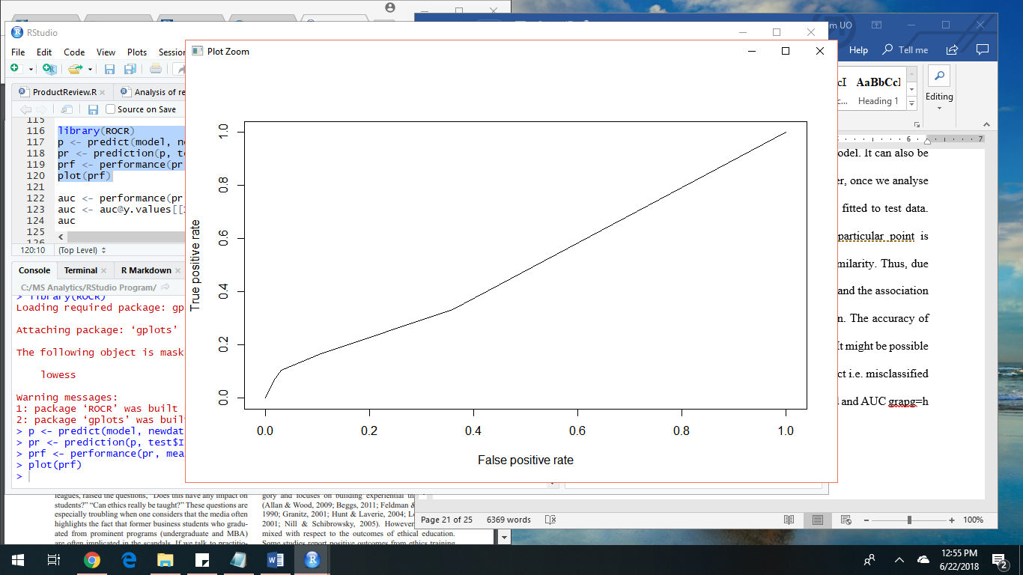

The X axis shows the number of values which are predicted incorrectly whereas the y axis the value which are predicted true. A graph which is more toward x-axis predicts that the model has misclassified the values. Hence, the model is not good enough. Whereas if the curve is more towards y axis it shows the model has predicted the values correctly and it is more than 50%. A model with 50% is not good enough. From the above graph it is clear that AUC is 50.3%. Hence, the null hypothesis is rejected.

Next method uses implementation of SVM kernel. SVM is a kind of supervised learning. SVM in a classification method. It categorizes the data with the help of a hyperplane. All the observation with common features is differentiated from other group with the help of the hyperplane. The distance between the hyperplane and the first value on each side of the line should have maximum value. For building this model we need to perform feature selection. Including all the values in the model won’t allow to give accuracy and result in overfitted. Thus reviews.text, reviews.numHelpful are the variables selected for building this model. Two new variables Is_It_Helpful, Wordcount is created. Is_It_Helpful variable is created based on reviews.numHelpful. Words count is created based on reviews.text variable.

Dependent Variable: WordCount, Is_It_Helpful

Independent Variable: reviews.numHelpful, reviews.text

WordCount is total number of words in text reviews. A function is used to find the word count and it will not count white space, comma, exclamation marks. Is_It_Helpful variable is used to find if a desired customer finds it helpful. The data will be spliced into training and testing data. There are 70% of data in training and rest of the 30% is the testing data. The dimension of the training data is 22757 by 6 whereas dimension of the testing data is 9751 by 6. All the observation with missing values should be removed from the subset of the data. The target value should be binary information. The model is trained based on observation from in the training. Setting seed is good practice. If the value of the seed is not set, then every time you run the model you will get different value to the model.

Conclusion

The objective of this project was to

References

Berger, J., Sorensen, T, A., & Rasmussen, J, Scott. (2010). Positive Effects of Negative Publicity: When Negative Reviews Increase Sales. *Marketing Science,* *29*(5), 815-827.

Bettman, J., Luce, M., & Payne, J. (1998). Constructive Consumer Choice Processes. *Journal of Consumer Research,* *25*(3), 187-217.

Ashby, N., Walasek, L., & Glockner, A. (2015). The effect of consumer ratings and attentional allocation on product valuations. *10*(2), 172-184.

Avery, C., Resnick, Paul, & Zeckhauser, Richard. (1999). The market for evaluations. *The American Economic Review,* *89*(3), 564-584.

Chen, Luo, & Wang. (2017). An influence framework on product word-of-mouth (WoM) measurement. *Information & Management,* *54*(2), 228-240.

Chevalier, Judith A., & Mayzlin, Dina. (2006). The effect of word of mouth on sales: Online book reviews. (Amazon.com and Barnesandnoble.com). *Journal of Marketing Research,* *43*(3), 9.

Clement, J. (2007). Visual influence on in-store buying decisions: An eye-track experiment on the visual influence of packaging design. *Journal of Marketing Management,* *23*(9-10), 917-928.

Dellarocas, Zhang, & Awad. (2007). Exploring the value of online product reviews in forecasting sales: The case of motion pictures. *Journal of Interactive Marketing,* *21*(4), 23-45.

Egan, Matt., (2016), Macy’s is Closing Another 100 Stores, Retrieved from http://money.cnn.com/2016/08/11/investing/macys-closes-100-stores/index.html

eMarketer (2017), Total Retail Sales Worldwide 2015-2020 trillion and % change, Retrieved from http://www.emarketer.com/Chart/Total-Retail-Sales-Worldwide-2015-2020-trillions-change/194243

eMarketer (2016), Internet Users rely on Reviews When Deciding Which Products to Purchase, Retrieved from  <https://www.emarketer.com/Article/Internet-Users-Rely-on-Reviews-Deciding-Which-Products-Purchase/1014465>

Fiske and Taylor, 1984, S.T. Fiske, S.E. Taylor Social cognition Addison-Wesley, Reading, MA (1984)

Hervet, G., Guérard, K., Tremblay, S., & Chtourou, M. (2011). Is banner blindness genuine? Eye tracking internet text advertising. *Applied Cognitive Psychology,* *25*(5), 708-716.

Jacob L. Orquin, Martin P. Bagger, & Simone Mueller Loose. (2013). Learning Affects Top Down and Bottom up Modulation of Eye Movements in Decision Making. *Judgment and Decision Making,8*(6), 700-716.

Loane, S., McNaughton, R., & Bell, J. (2004). The Internationalization of Internet‐Enabled Entrepreneurial Firms: Evidence from Europe and North America. *Canadian Journal of Administrative Sciences / Revue Canadienne Des Sciences De L'Administration,* *21*(1), 79-96.

Lohse, G. (1997). Consumer Eye Movement Patterns on Yellow Pages Advertising. *Journal of Advertising,* *26*(1), 61-73.

Luzardo, Rivest, Alonso, & Ludvig. (2017). A drift–diffusion model of interval timing in the peak procedure. *Journal of Mathematical Psychology,* *77*, 111-123.

McNamara, D. S., Kintsch, E., Songer, N. B., & Kintsch, W. (1996). Are good texts always better? Interactions of text coherence, background knowledge, and levels of understanding in learning from text. Cognition and Instruction, 14, 1–43.

[Michel Wedel,](http://www.emeraldinsight.com/author/Wedel%2C+Michel) [Rik Pieters,](http://www.emeraldinsight.com/author/Pieters%2C+Rik)(2008), A Review of Eye-Tracking Research in Marketing, in Naresh K. Malhotra (ed.) Review of Marketing Research (Review of Marketing Research, Volume 4) Emerald Group Publishing Limited, pp.123 – 147

Oliver, R.L. 1997. Satisfaction: A Behavioral Perspective on the Consumer. Boston: McGraw Hill

Park, D., Lee, J., & Han, I. (2007). The Effect of On-Line Consumer Reviews on Consumer Purchasing Intention: The Moderating Role of Involvement. *International Journal of Electronic Commerce,* *11*(4), 125-148.

Rayner, K. (1998). Eye movements in reading and information processing: 20 years of research. Psychological Bulletin, 124, 372–422.

Sarmah, U., & Sarma, M. (2011). Service Quality Check: Online Shopping. *SCMS Journal of Indian Management,* *8*(4), 5-10.

Stevens, Rob. (2007). Like more, look more. Look more, like more: The evidence from eye-tracking. *The Journal of Brand Management,* *14*(4), 335-342.

Shinsuke Shimojo, Claudiu Simion, Eiko Shimojo, & Christian Scheier. (2003). Gaze bias both reflects and influences preference. *Nature Neuroscience,* *6*(12), 1317-22.

Tausczik, Y. R., & Pennebaker, J. W. (2010). The psychological meaning of words: LIWC and computerized text analysis methods. Journal of Language and Social Psychology, 29, 24–54.

Tsao, W., & Tseng, Y. (2011). The impact of electronic-service quality on online shopping behavior. *Total Quality Management & Business Excellence,* *22*(9), 1007-1024.

Utz, Kerkhof, & Van Den Bos. (2012). Consumers rule: How consumer reviews influence perceived trustworthiness of online stores. *Electronic Commerce Research and Applications,* *11*(1), 49-58.

Voight, Joan. (2007). Getting a handle on customer reviews: Brands tell consumers: If you have something to say, say it on our site. (Customer Relations). *ADWEEK,* *48*(26), 6.